Weyland Bulletin – September 2026
See you in Hamburg – and thank you
Noah Fischer · 29 September 2026
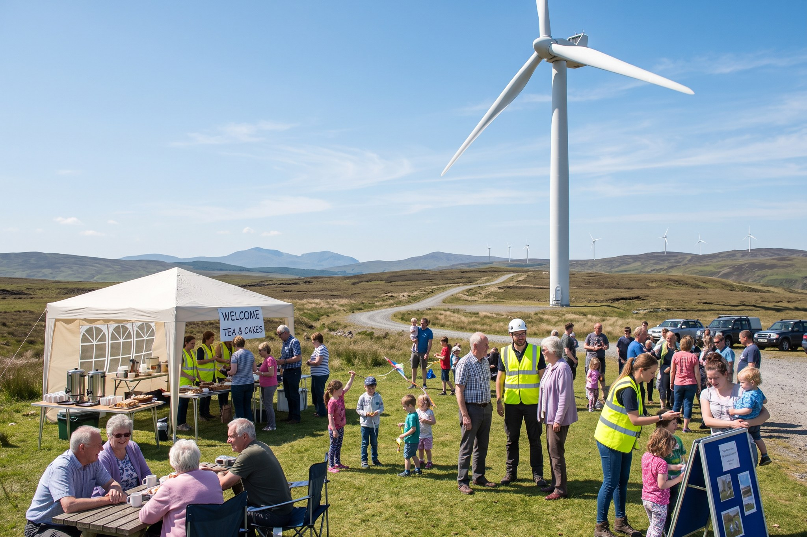

See you in Hamburg – and thank you
The North Sea Energy Summit (22–24 September) brought more than 600 visitors to booth B4.210.

Project update
Project | Status
Harrow Bay | 13 of 40 monopiles installed by the end of September
Kestrel Ridge | 12.4 GWh generated in August
Millbrook | Application MDC/2026/0412 under consideration
Fenwick | Grid application submitted in July

Millbrook: our third public consultation on 16 September focused on glare, construction traffic on Mill Lane and skylark habitat. A summary of what we heard follows in November.

People
Our Lunch & Learn on hydrogen with Isabel Ferreira had 120 listeners – the recording is on the intranet.
Weyland Bulletin is sent to 3,800 subscribers. Unsubscribe at any time.

